# Cyclomatic Complexity Redundancy index results

The cyclomatic complexity redundancy index was obtained from all the project and only for those files where the development team since Renesas/Synergy software add code and functions that increase the metrics.

The code can be cleaned up to reduce the metrics; nevertheless, that activity is considered out of the scope and not required by the customer.

## Results

The results cover the following files since in those files the development team implement the project.

* ADC_Thread_entry(  void )
* Display_Thread_entry(  void )
* IC_Thread_entry(  void )
* Refresh_Screen(   )
* error_trap(  char *,  ssp_err_t )
* g_lcd_spi_callback(  spi_callback_args_t * )
* initialise_monitor_handles(  void )
* input_capture_callback(  input_capture_callback_args_t * )
* input_capture_hal_module_guide_project(   )
* input_capture_hal_module_guide_project(  void )
* setDutyCycle(  ULONG )
* setSetPoint(  ULONG )
* setSpeed(  ULONG )
* show_window(  GX_WINDOW *,  GX_WIDGET *,  bool )
* ssp_touch_to_guix(  sf_touch_panel_payload_t *,  GX_EVENT * )
* stateMachine(  int * )
* update_text_id(  GX_WIDGET *,  GX_RESOURCE_ID,  UINT )
* window1_handler(  GX_WINDOW *,  GX_EVENT * )
* window2_handler(  GX_WINDOW *,  GX_EVENT * )

### Detailed report

The detailed report includes the functions listed in the previous section

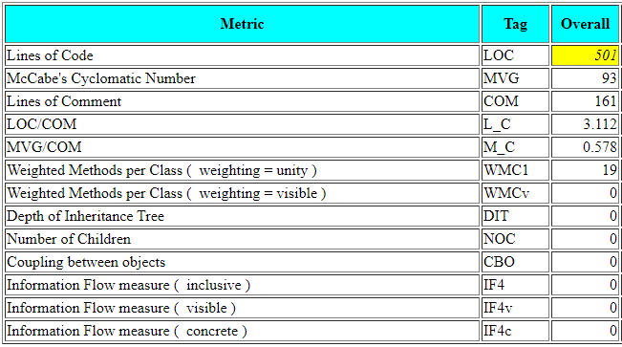

#### Lines of Code

As can be observed, the Lines of Code is the only category in yellow and that is because the analyzer is telling us that the files have more lines than recommended. However, this not necessarily means that is incorrect or need to fixed. On the other hand, the development team has decided do not reduce the lines per files because some are Renesas/Synergy generated. In other words, Renesas/Synergy will overwrite the code if it is needed to change the configuration.

#### McCabe's Cyclomatic Number

For the McCabe's Cyclomatic Number, the metric obtained is 93. This means that in overall, the functions are not complex. The analyzer recognizes less than 100 paths. This is the result of the design. From the design, there was proposed to use an architecture that simplifies the load of complexity like a good balance of threads and the use of a distributed state machine.

## Results by function.

